## ICTPRG430 - Apply introductory object-oriented language skills.

## Online Debugging: https://replit.com/@HemantDubey1/OvercookedFrailNormalform

## **Was unable to read file:**

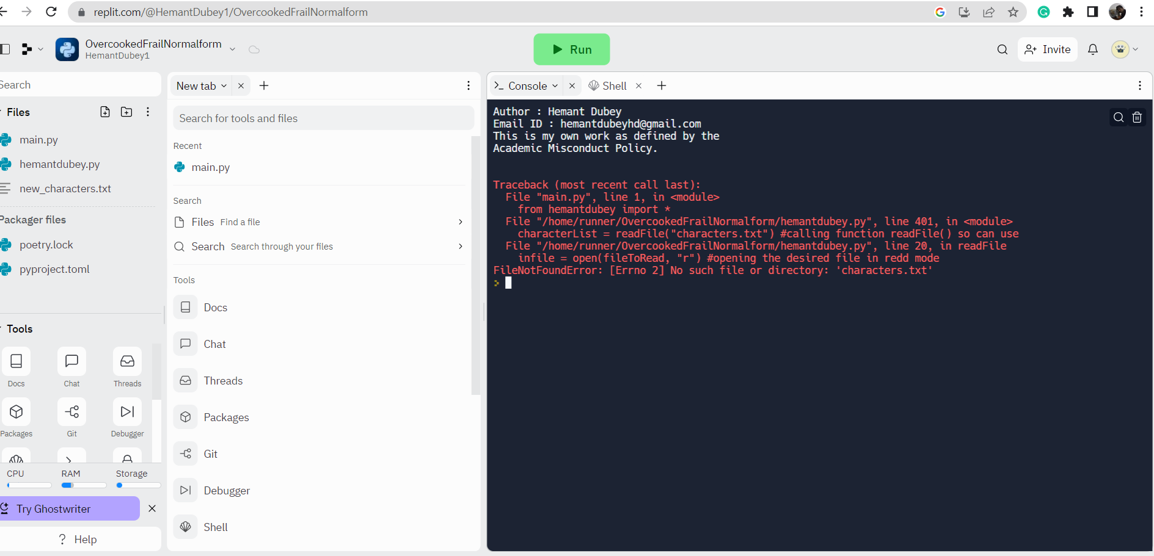

## **Rectified and can run:**

## **Command “Read”:**

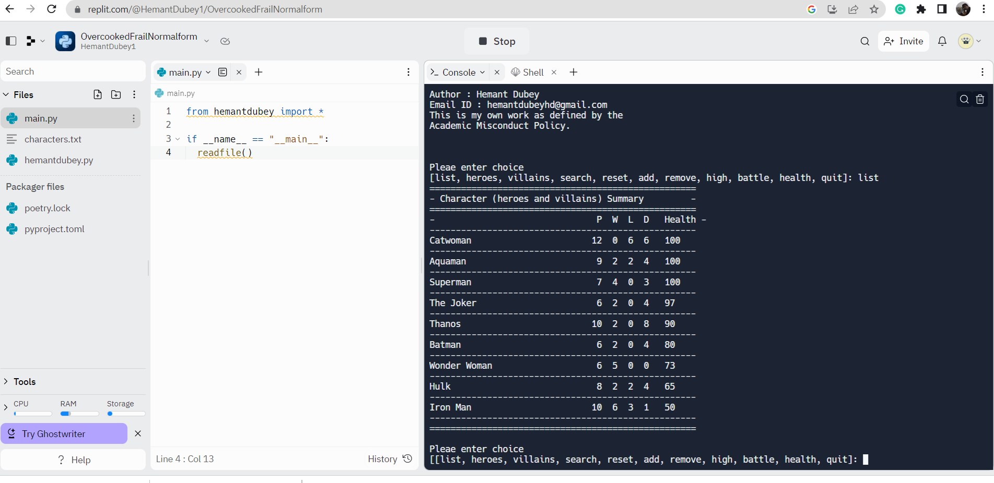

## **Command “heroes”**

## **Command “villains”**

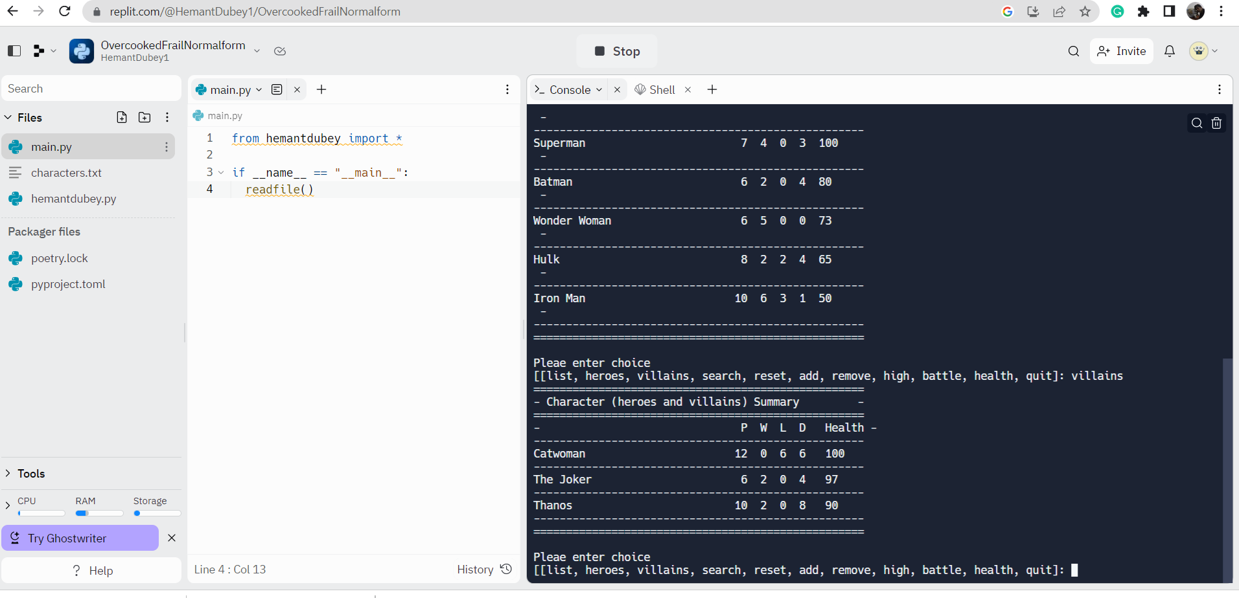

1. **Command “search” with right input**

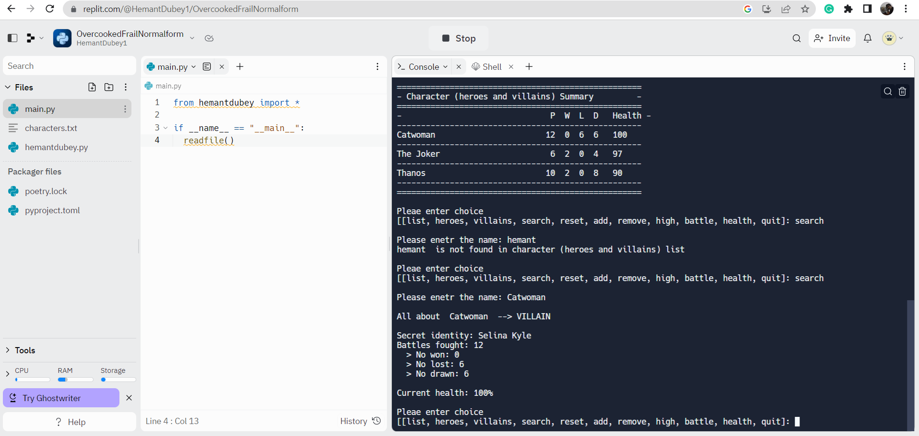

1. **Command “reset”**

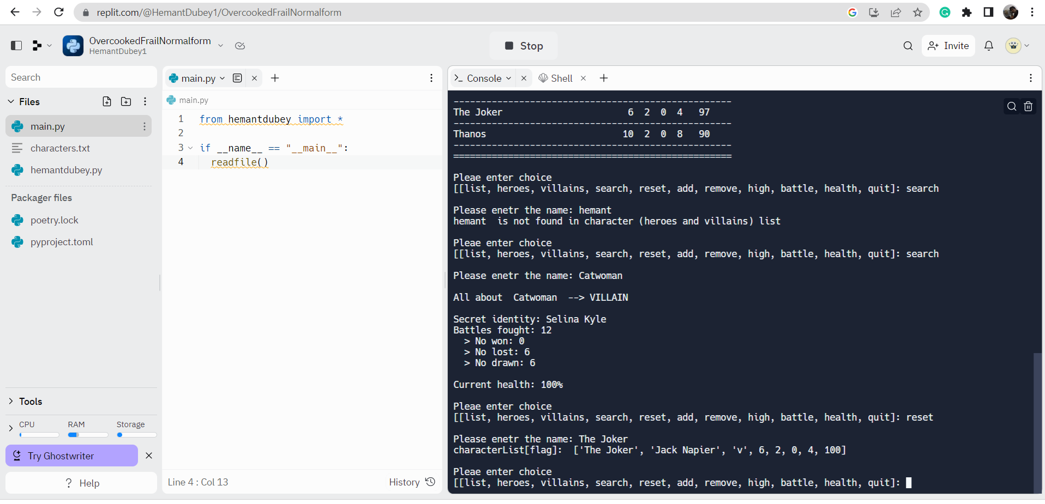

1. **Command “add”**

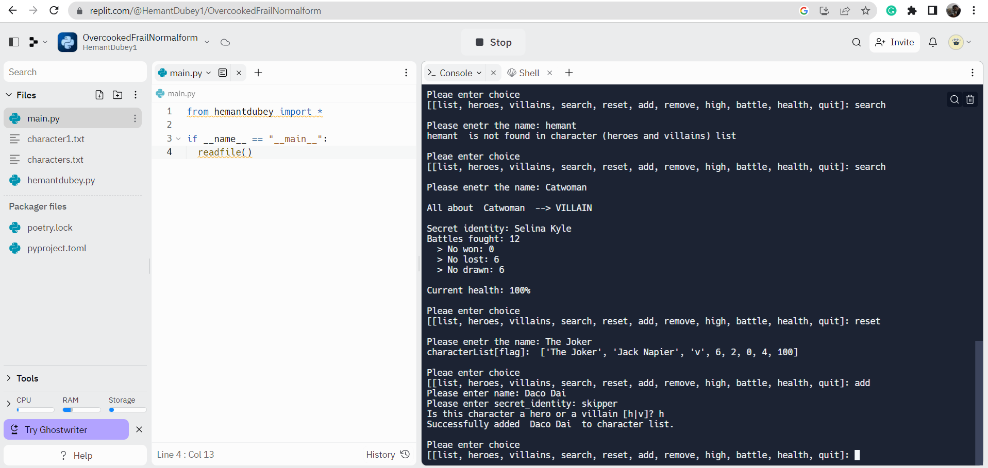

Character added(proof):-

1. **Command “remove”**

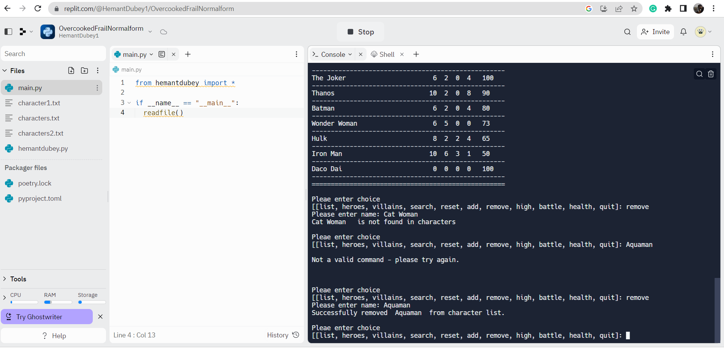

1. **Command “high”**

Health:-

1. **Command “health”**

(Displays the list of characters in descending order of health.)

1. **Command “battle”**

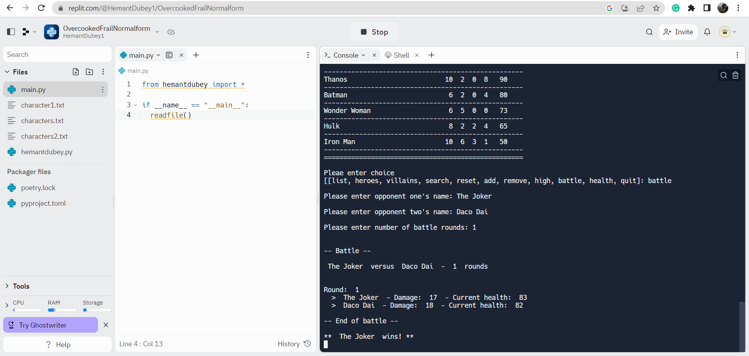

1. **Command “quit”**

